CREATE PROCEDURE d_any_table(p_table_name VARCHAR2) IS

BEGIN

EXECUTE IMMEDIATE 'DROP TABLE ' || p_table_name;

END;

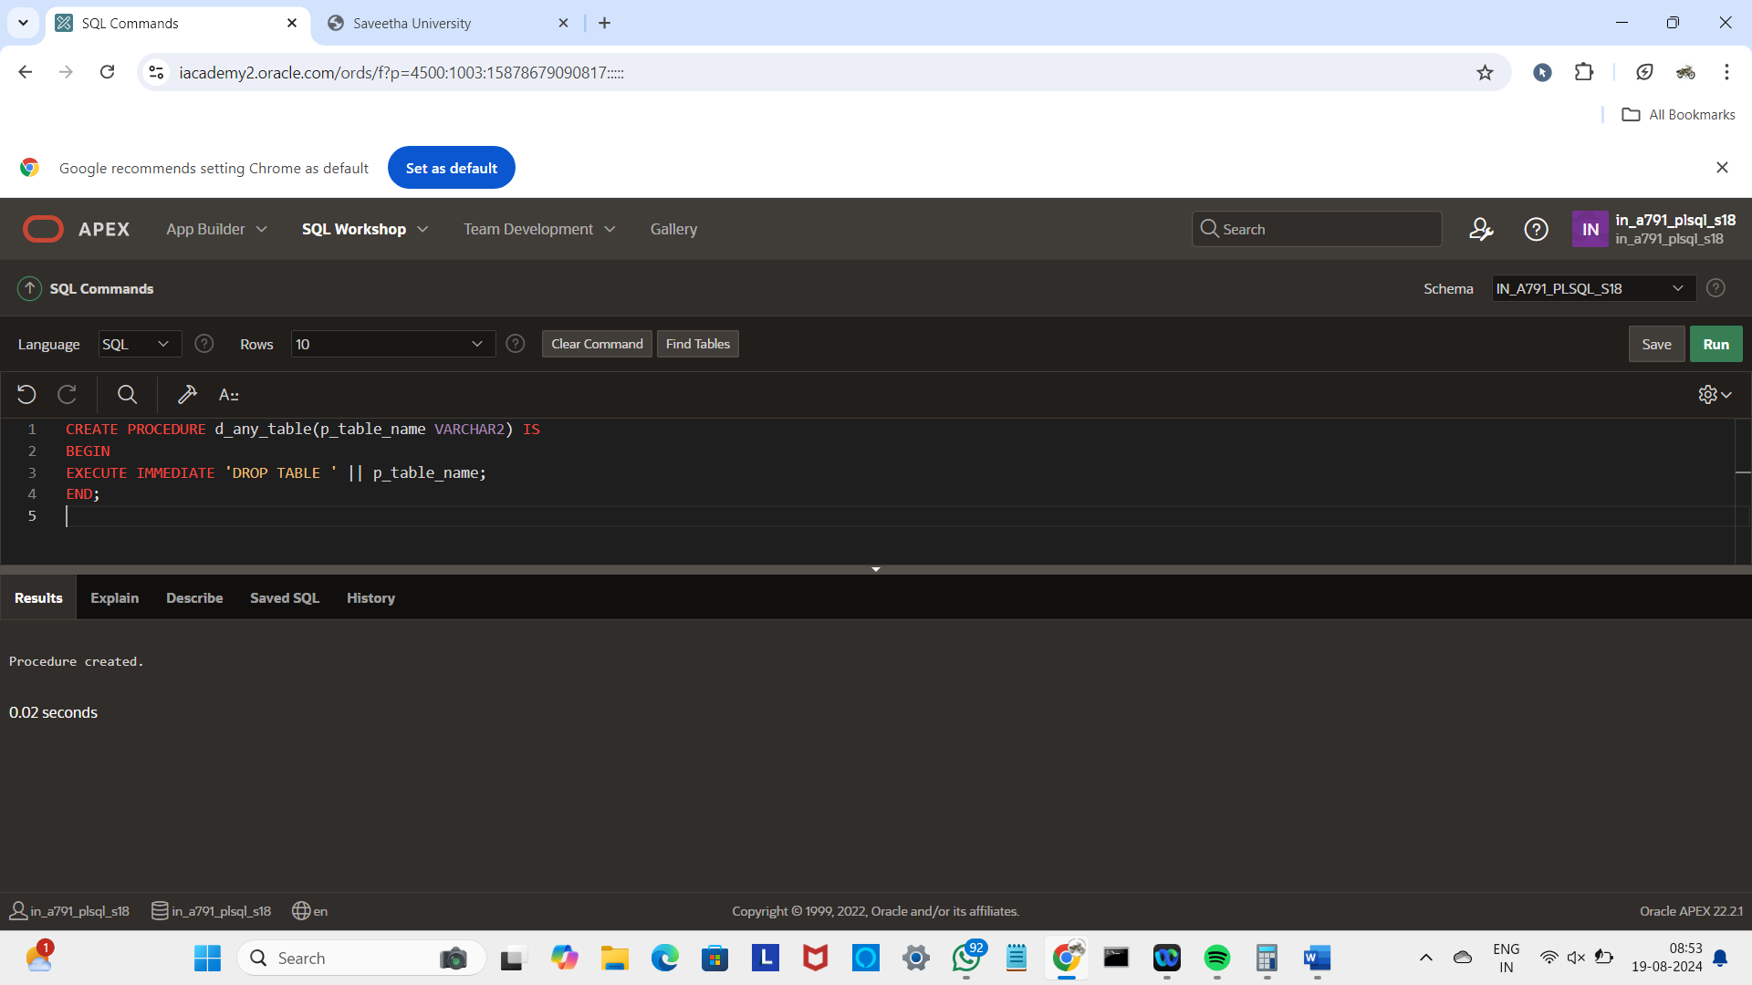

BEGIN d_any_table('EMPLOYEE');

END;

